**NAME : Arshia Noonari**

**STUDENT ID : BIT-24S-008**

**DEPARTMENT : INFORMATION TECHNOLOGY**

**SUBJECT : ARTIFICIAL TECHNOLOGY**

**Python looping tasks:**

**Task:1**

**Print numbers from 1 to 10 using a for loop**

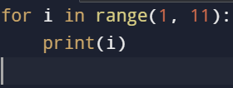

**OUTPUT**

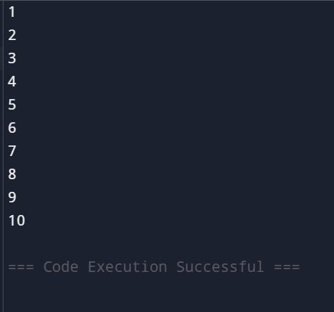

**TASK:2**

**Print all even numbers between 1 and 20 using a loop**

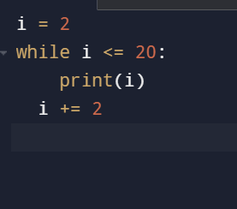

**OUTPUT**

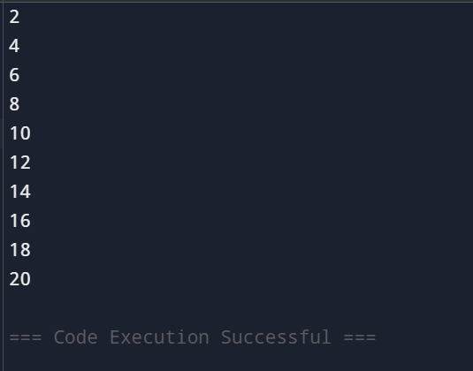

**TASK:3**

**Calculate the sum of numbers from 1 to 100 using a loop**

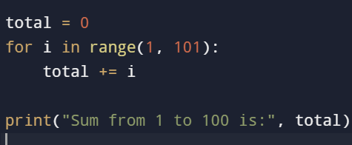

**OUTPUT**

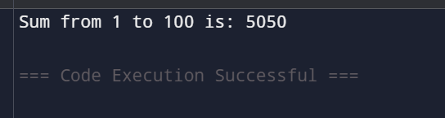

**TASK:4**

**Print the multiplication table of 5 using a loop**

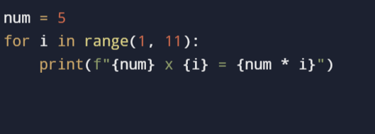

**OUTPUT**

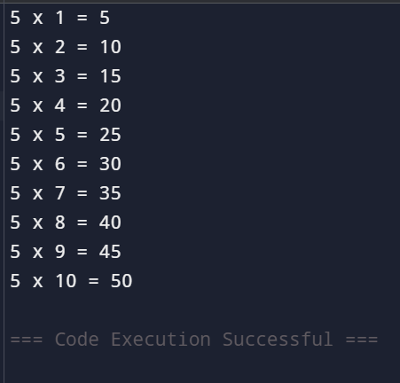

**TASK:5**

**Find the factorial of a given number using a** for **loop**

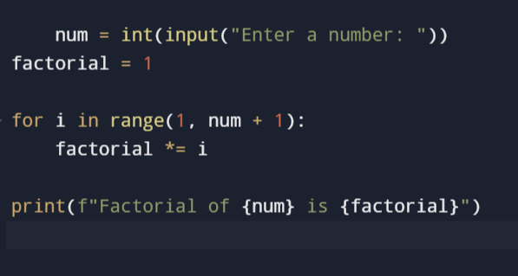

**OUTPUT**

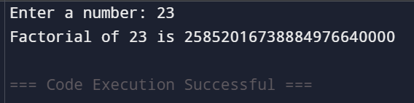

**TASK:6**

**Iterate over a list of fruits and print each item**

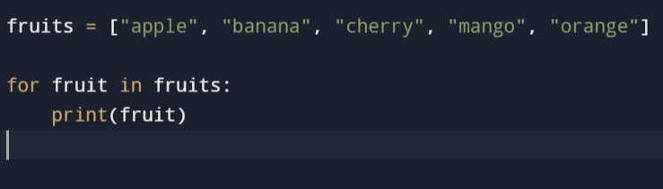

**OUTPUT**

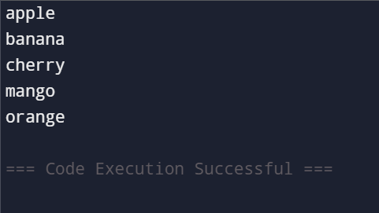

**TASK:7**

**Create a list of numbers and print only the odd numbers using a loop**

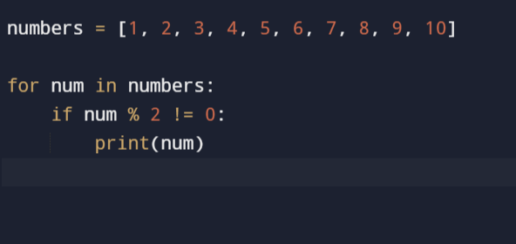

**OUTPUT**

